试卷与题库分类结构：  
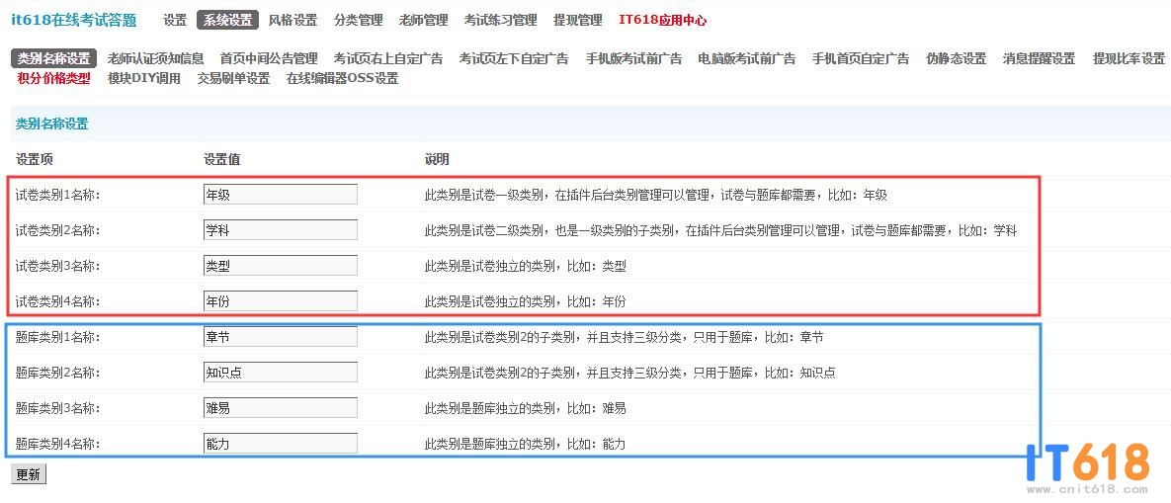   
  
  
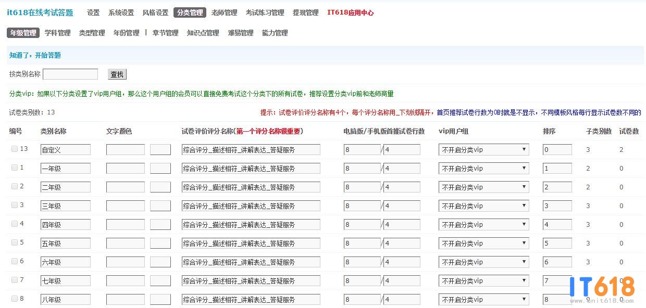   
  
  
题库题目数据库结构（下面的分类名称以上面的分类名称为例说明）：  
  
**题目库**  
CREATE TABLE IF NOT EXISTS `pre_it618_exam_questions` (  
  `id` int(10) unsigned NOT NULL AUTO_INCREMENT,  
  `it618_shopid` int(10) unsigned NOT NULL default '0', 老师id  
  `it618_class1_id` int(10) unsigned NOT NULL, 年级id  
  `it618_class2_id` int(10) unsigned NOT NULL, 学科id  
  `it618_qclass11_id` int(10) unsigned NOT NULL, 一级章节id  
  `it618_qclass12_id` int(10) unsigned NOT NULL, 二级章节id  
  `it618_qclass13_id` int(10) unsigned NOT NULL, 三级章节id  
  `it618_qclass21_id` int(10) unsigned NOT NULL, 一级知识点id  
  `it618_qclass22_id` int(10) unsigned NOT NULL, 二级知识点id  
  `it618_qclass23_id` int(10) unsigned NOT NULL, 三级知识点id  
  `it618_qclass3_id` int(10) unsigned NOT NULL, 难易id  
  `it618_qclass4_id` int(10) unsigned NOT NULL, 能力id  
  `it618_qtypeid` int(10) unsigned NOT NULL default '0', 题型id  
  `it618_name` varchar(1000) NOT NULL, 题目名称  
  `it618_value` varchar(1000) NOT NULL, 简答题时的答案内容  
  `it618_isok` int(10) unsigned NOT NULL, 判断题时的答案  
  `it618_order` int(10) unsigned NOT NULL, 题目排序  
  PRIMARY KEY  (`id`)  
) ENGINE=MyISAM;  
  
**题目选项库(单选题、多选题、填空题)**  
CREATE TABLE IF NOT EXISTS `pre_it618_exam_questions_option` (  
  `id` int(10) unsigned NOT NULL AUTO_INCREMENT,  
  `it618_qid` int(10) unsigned NOT NULL default '0', 题目id  
  `it618_name` varchar(1000) NOT NULL, 选项内容  
  `it618_isok` int(10) unsigned NOT NULL, 选项是否为答案项  
  `it618_order` int(10) unsigned NOT NULL, 选项排序  
  PRIMARY KEY  (`id`)  
) ENGINE=MyISAM;  
  
  
**题型库**  
CREATE TABLE IF NOT EXISTS `pre_it618_exam_qtype` (  
  `id` int(10) unsigned NOT NULL AUTO_INCREMENT,  
  `it618_typename` varchar(255) NOT NULL,  
  `it618_order` int(10) unsigned NOT NULL,  
  PRIMARY KEY  (`id`)  
) ENGINE=MyISAM;  
  
  
INSERT INTO `pre_it618_exam_qtype` (`id`, `it618_typename`, `it618_order`) VALUES  
(1, '单选题', 1),  
(2, '多选题', 2),  
(3, '填空题', 3),  
(4, '判断题', 4);